SPSS – Opening Files (VDI Only)

When trying to access files using remote desktop, it is not obvious on where the files are stored. Since files are not stored on the remote desktop server but are stored locally or on the network drive, users will have to navigate to their files.
- To access your Uwaterloo OneDrive, you must first log into OneDrive through Portal.office.com
- Click on the “Open data document” (folder icon) at the top left of the main SPSS window.
On the “Open Data” window, click on the “Look in:” drop-down menu. In the drop-down menu, find and select One Drive – University of Waterloo entry.
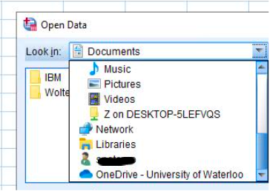
- You will now see a list of folders found in VDISRV. Ignoring the folders (Desktop, documents, Downloads), look for folders that have names such as “C on [computer name]”, “N on [computer name]”, “Users on [computer name]”, or \\files.uwaterloo.ca or OneDrive – University of Waterloo. These entries will have an icon with a small green upside-down T.
- Navigate to where your file is located.
  - On home Windows machines, locally saved files can be found by going to “C on [computer name]”, then to the “Users” folder, and then to the folder with your account name.
  - Mac users that have configured Remote Desktop to have their “Users” folder visible can navigate to locally saved files by selecting “Users in [computer name], and then the folder with your account name

