Composite Materials Activity
Resin Infusion Method Quick Start Guide
  - Engineering IDEAS Clinic Winter 2021

Document prepared by:
Gavin Jiawen Liu, 20880292, Chemical
Terese Dimeck, 20788713, Nanotechnology
Matthew Muir, 20851400, Nanotechnology
Faculty of Engineering
University of Waterloo
January 21, 2020
* Open file on desktop app of MS Word to ensure photo formatting is correct

Table of Contents
1. Background and Context 2
1.1. Introduction 2
1.2. Objective 2
2. Preparation 2
2.1. Background Knowledge Needed 2
2.2. Materials and Apparatus 2
3. Directions 3
3.1. Procedures 3
3.2. Procedure Design 4
3.3. Visual Guide 6
3.4. Video Example 7

Background and Context

Introduction
In this document, you will find the step-to-step guide to create a simple flat composite sheet using the Resin Infusion manufacturing method. This method is a substitute to the Hand Layup or Vacuum Bagging Methods, and decreases the amount of time needed for large pieces. Disadvantages include a large preparation time, and the risks for leaks. Refer to the Reference Sheet Document regarding other technical questions and information. Ensure you have read through this document, the advantages, disadvantages, risks, and understand the process and safety precautions prior to conducting the experiment.
* Prior knowledge and experience with Hand Layup or Vacuum Bagging is not required, but is recommended as good starting points; Resin infusion is significantly more difficult with more factors to consider.

Objective
- To Create a flat composite sheet using fiberglass or carbon fibers.
- Learn about the Resin Infusion (closed molding) production method.
- Start to think about why this production method is prevalent, considering its positives and negatives, and contrasting them to other methods.

Preparation

Background Knowledge Needed
- Understand how fiber orientation will change directional strength of your product.
- Briefly familiarize yourself by going over the Reference Sheet Document.
- Have an understanding on FVF, and how it can affect overall mechanical properties.
- Effects strength/flexibility
- General reference: 50/50 by mass FVF for hand layup
- Understand that 2:1 resin to hardener ratio is the general rule (if not specified by the specific resin and hardener label; refer to product labels)
  - 2:1 ratio example: 500g fibers, 333g resin, 167g hardener
- Depending on the resin used, the mixture may heat up during the process; mix epoxy and hardener in a non-temperature sensitive container.

Materials and Apparatus
- Reinforcement (Carbon Fiber)
- Epoxy Infusion Resin (Low Viscosity)
- Hardener (Paired With Specific Infusion Resin)
- Release Agent
- Mold or Glass Surface
- Peel ply
- Breather Cloth
- Infusion Mesh
- Vacuum Pump
- Catch pot
- Resin Feed Tubes
- Spiral Resin Tubing
- Gum Tape
- Vacuum Bag
- Through-bag Connector

Directions

Procedures
- Cut the vacuum bag a reasonable amount larger than the surface area of the pot of carbon fiber (mold or on surface). At least double the length or width so that the vacuum bag can cover the top of the piece as well.

- Cut the peel ply a size larger than the surface area of the pot of carbon fibre, but less than the vacuum bag. Cut the infusion mesh a size larger than the surface area of the pot of carbon fibre, but less than the peel ply.

- Gum tape is applied on 4 sides of the vacuum bag, this ensures that the seal around the composite sheet is tight once in vacuum. Make sure that the seal is tight (and avoid getting creases between the tape and the bag) to ensure an airtight fit.

- Get out your glass sheet or mirror which will be used as the surface for the laminate and place it on a flat table.

- Make sure the surface of the glass is clean by removing any dust particles and wiping it down with acetone.

- Once surface has been cleaned, apply your release agent. This can be either sprayed on or wiped on using cloth or paper towel. If the release agent is being sprayed on, apply a light first layer and let it cure, then apply a thicker second layer.

- While the release agent is drying you can prepare your resin. First, weigh your carbon fiber sheets that you are using. Typically, the FVF for a hand-layup is 50%. After you have weighed your carbon fiber you can add and mix the correct amount of epoxide and hardener to the mixing cup and mix well (make slightly more resin than needed to account for errors).

- Place the fibre onto the tool or working surface, and cover with a layer of peel ply. Tape down the 4 corners of the peel ply to the surface of the tool to prevent displacement.

- Lay the infusion mesh onto the peel ply and tape it down. Leave a small space where there is just peel ply, this is called a resin break. This will slow down the flow of the resin when it reaches the peel ply.

- Lay out the spiral resin tubing along 3 sides of the infusion mesh. Place a resin feed center of the side perpendicular to the other 2.

- Place a through-bag connector onto just the peel ply section, opposite the resin feed.

- Insert the composite piece into the vacuum bag, then seal the last side with gum tape. (or simply seal down the vacuum bag)

- Carefully puncture the bag at the connection points: the resin feed and the through-bag connector. Connect the resin feed connector to resin reservoir via tubing. Connect the through-bag connector to vacuum via tubing and catch pot. Ensure that seals between connectors and tubing is good by applying some gum tape.

- Apply pressure onto the resin tube using your hands, or a clamping tool and turn on the vacuum. Once the vacuum is around -25 to -28 psi, allow vacuum to hold for at least 15 mins to check for any leaking.

- Release pressure to the inlet resin tube. The resin will now start flowing into the bag; keep constant vacuum on.

- Once all the resin in reservoir is gone, clamp the resin tube again. Keep vacuum on until it reaches -25 to -28 inhg then turn it off.

- When the bag is contracting, physically manipulate it to ensure that the vacuum bag is tightly and smoothly contacting the composite piece.

- When done curing, remove the peel ply and breather layer. Use some sort of wedge to pry the sheet from the glass (shouldn’t be too hard with release agent) and remove peel ply if it was used earlier. Cut the fiber sheet to the dimensions desired.

- You have now made a sheet of carbon fiber using the Resin Infusion Method!

Procedure Design
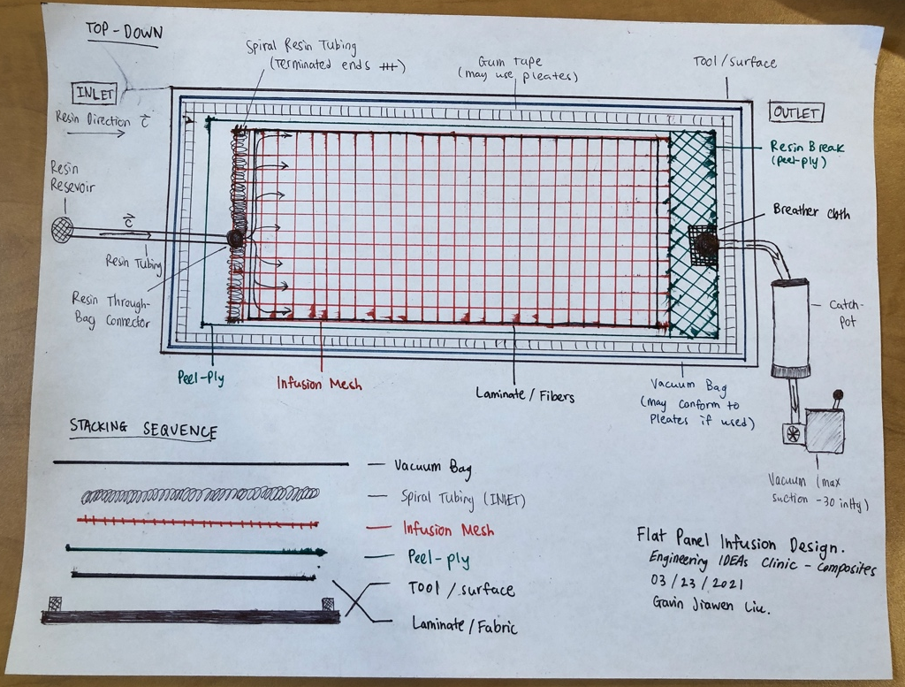

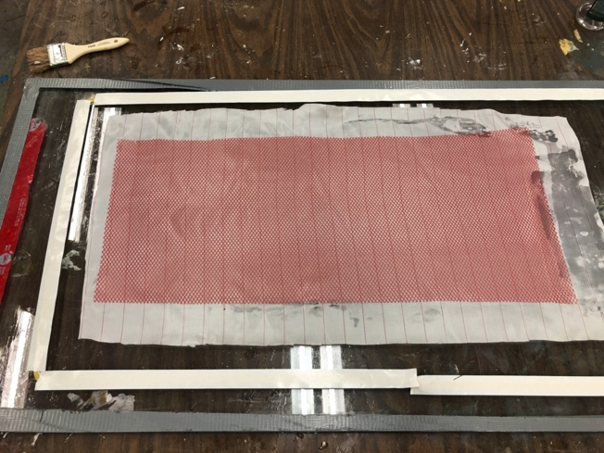
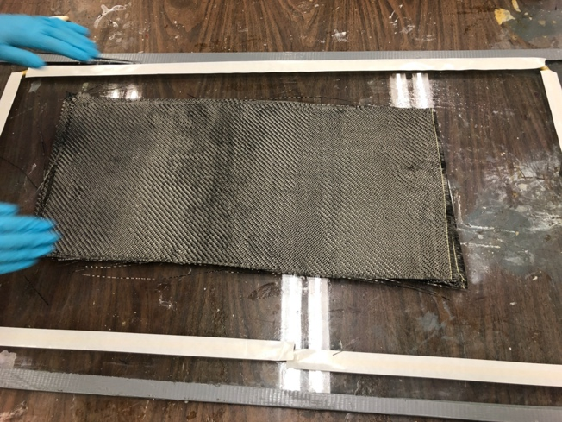
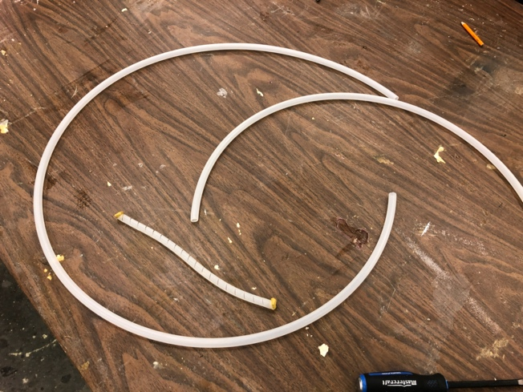
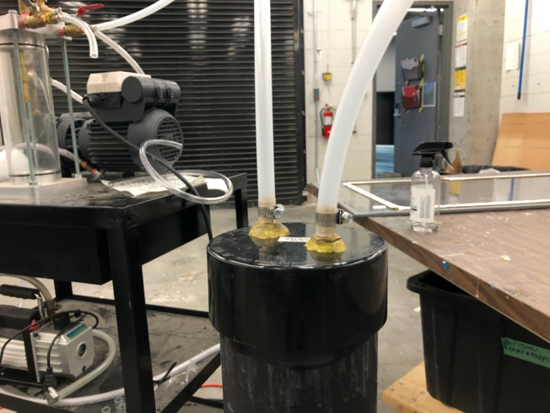
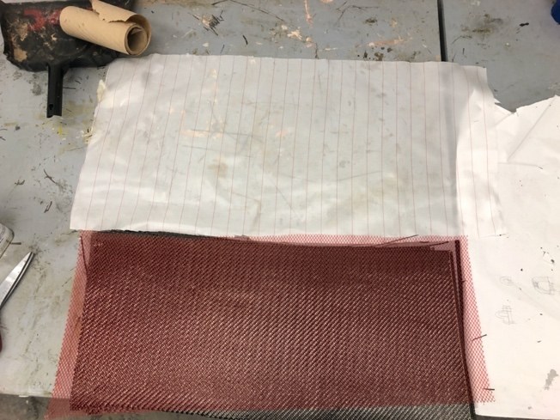
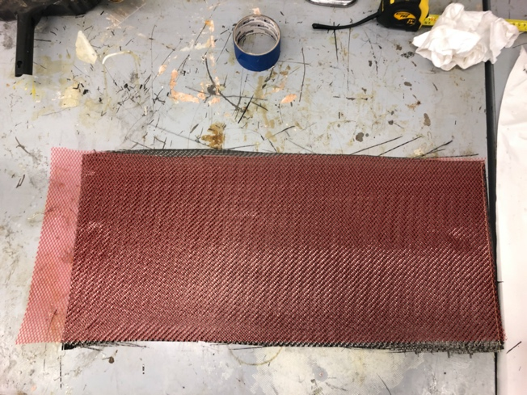
Visual Guide
Step 6: Lay the process materials onto the fibre. Lay the peel ply first, then infusion mesh. Ensure that peel ply is larger than both the fibre and the mesh.
Step 5: Apply wax/PVA on the working surface. Lay the fibres according to the stacking sequence.
Step 3: Cut 2 infusion tubes to size. Ensure that the length is enough for reach the reservoir for the inlet, and the catch pot for the outlet. Cut spiral tubes to the width of the fibres. Seal the ends of the spiral tube with gum tape.
Step 4: Connect the outlet infusion tubing to the catch pot. To further secure it’s connection and to prevent possible leaks, use a hose clamp. Use gum tape if leaks persist.
Step 2: Cut the peel ply larger than both the fabric and the infusion mesh in length and width; This peel ply should take off all process materials once peeled after infusion is complete.
Step 1: Cut infusion mesh the same width as the fabric, add about 1 inch to 1½ inch of length to accommodate the resin inlet spiral tubing.
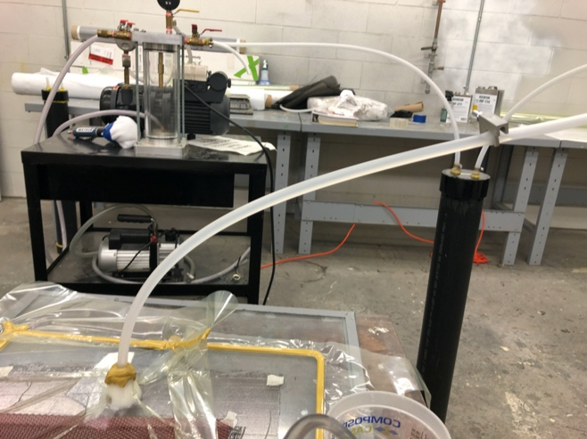
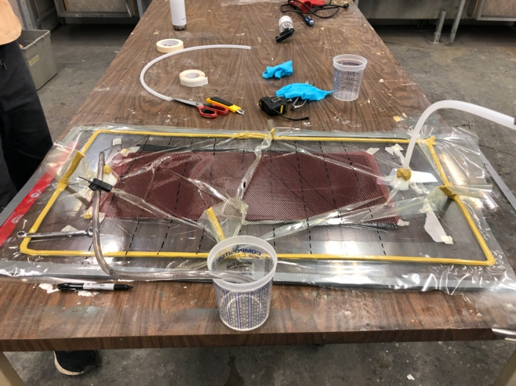
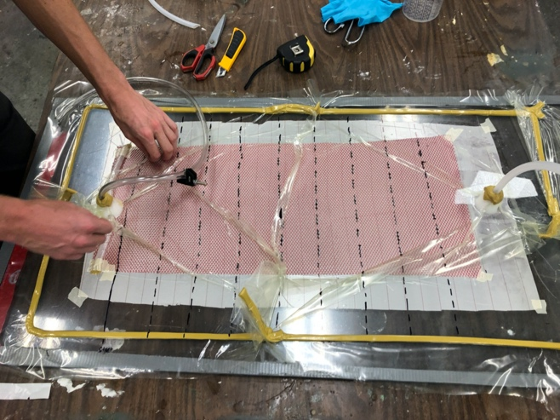
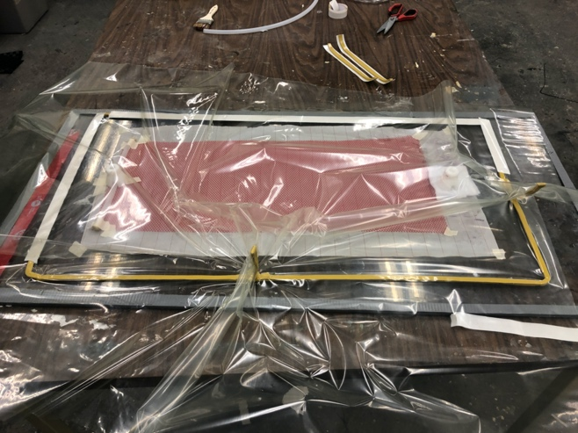
Step 10: Once the resin flow front reaches the resin break, clamp off the inlet and outlet. Turn off the vacuum once both inlet and outlet are clamped. Check for leaks. Allow the piece to cure.
Step 9: Add clamps to the inlet and outlet. Mix resin and place in resin reservoir. Close the inlet clamp. Start vacuum (vacuum stays on during the infusion), once full pressure is reached open the outlet.
Step 8: Ensure that vacuum seal is tight; run full vacuum for 10 – 15 mins to check. Use heat gun to further ensure seal. Connect the inlet resin tubing to the reservoir. Connect the outlet resin tubing to the catch pot.
Step 7: Tape the spiral tubing down to the infusion mesh. But resin through bag connectors at the intended inlet and outlet locations. Put vacuum bag with pleating.

Video Example
* Online Video Reference:
In-Depth Guide to Resin Infusion (3m Kevlar Moulding)
